Revise the sensor listing app so that the sensor values are displayed in a chart. You may use any charting library. The chart should display the most recent 30-second of the data collected for each sensor.

Mainactivity.java : To successfully acquire and visualize sensor data, we need to use several critical methods and functionalities. The 'onCreate()' method starts the program by configuring GraphViews and registering sensor listeners. 'initializeGraphViews()' configures the GraphView elements, whereas 'registerSensorListeners()' registers Accelerometer, Gyroscope, and Light Sensor listeners. The GraphView settings are customized using the 'setupGraph()' function. When sensor data changes, the 'onSensorChanged(SensorEvent event)' method logs and updates each sensor type's LineGraphSeries. 'onResume()' re-registers sensor listeners during app resume, and 'onPause()' unregisters them for effective resource management. These components work together to record and visualize accurate real-time sensor data.

Note : Additionally, I added the zoom in/out functionality with the `setScalable(true)` and `setScalableY(true)` functions and displays sensor names and values on the x-axis by default, contributing to an enhanced user experience and potentially earning extra credits.

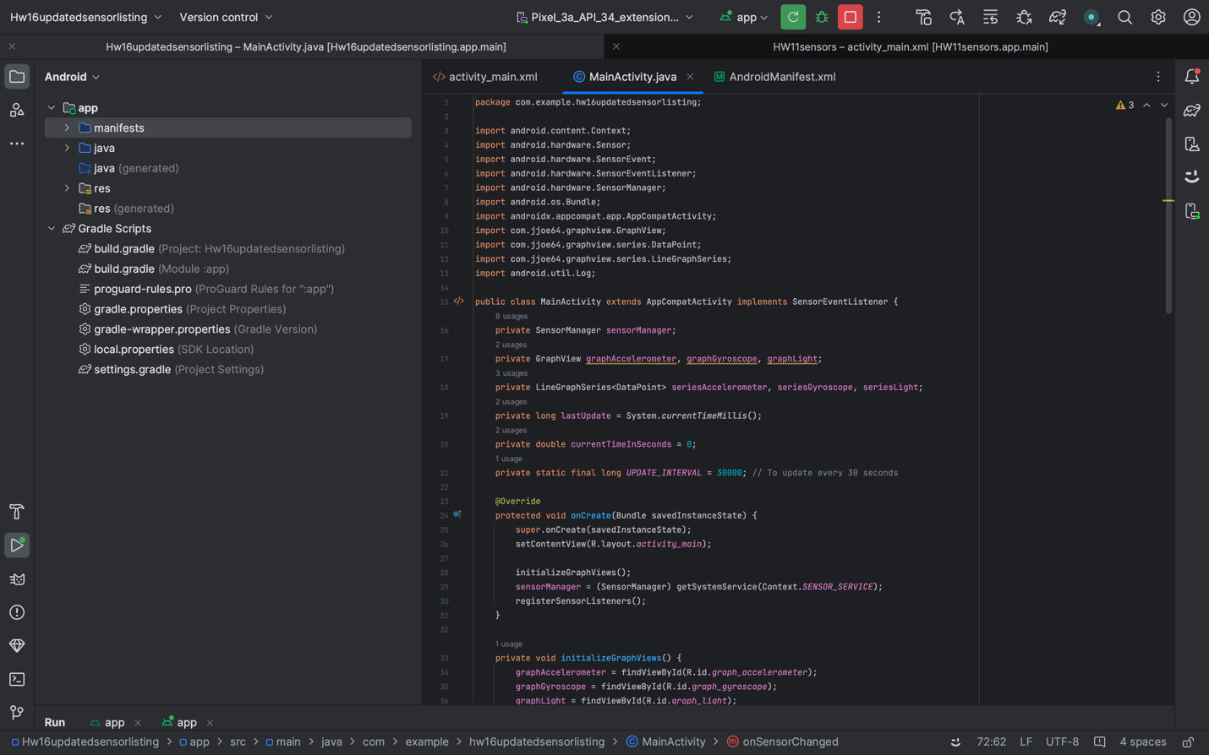

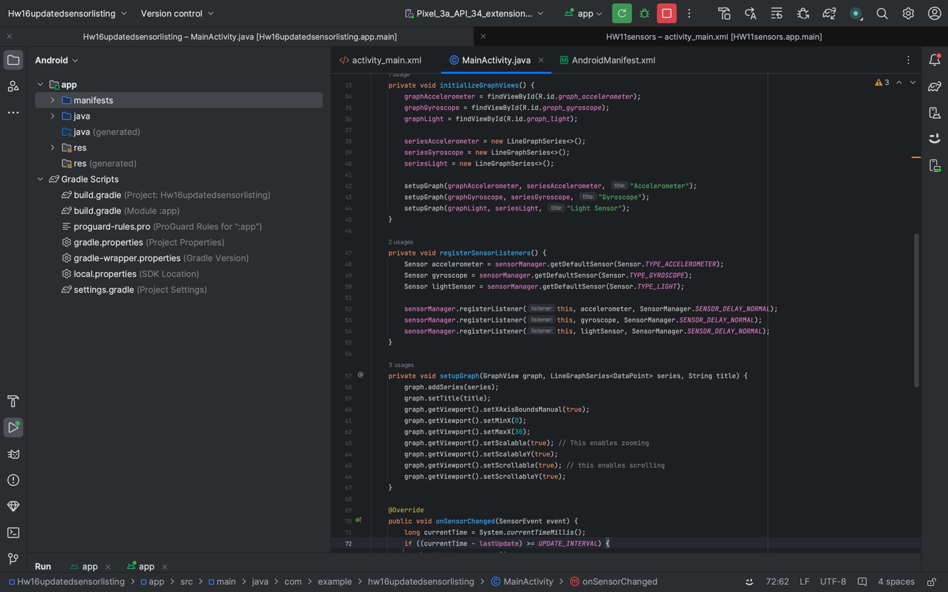

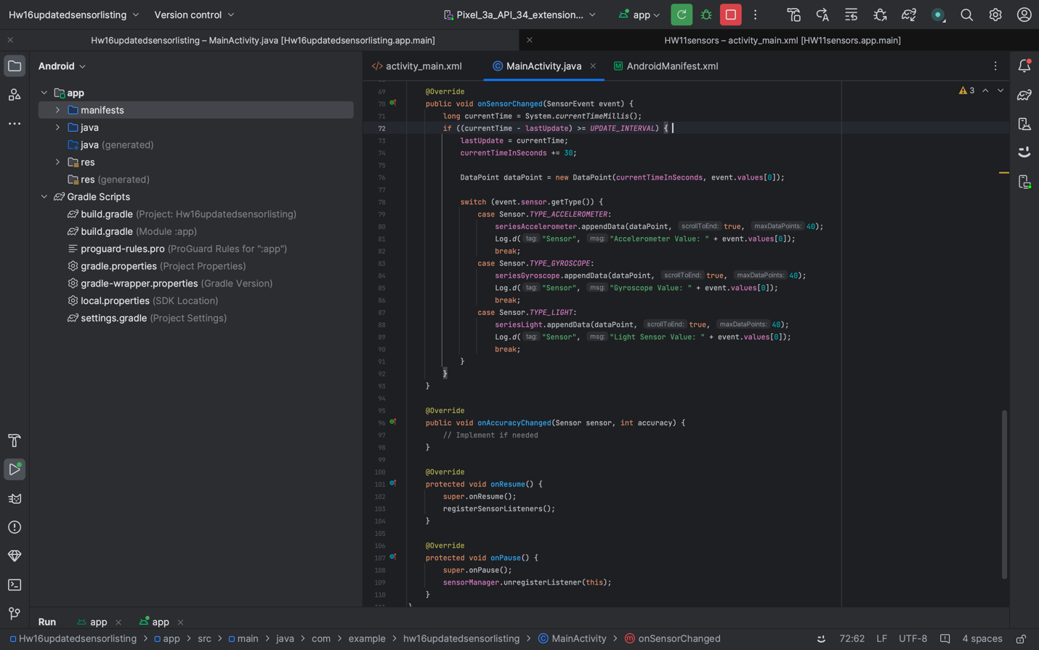

Activity_main.xml : The XML layout code defines the main user interface for the activity of the Android app. It features three vertically stacked 'GraphView' elements for viewing sensor data (accelerometer, gyroscope, and light sensor). Below them is a 'ScrollView' with a 'TextView' that displays a list of sensor data. The design guarantees that sensor data is visually displayed by graphs and that it may be scrolled through in text format.

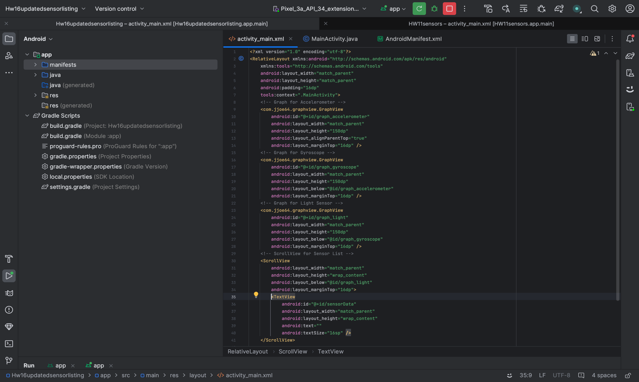

Gradle properties : In the `gradle.properties` file, we need to use the line "android.useAndroidX=true" to enable AndroidX libraries, and "android.enableJetifier=true" is included to enable automatic migration of third-party libraries for AndroidX compatibility.

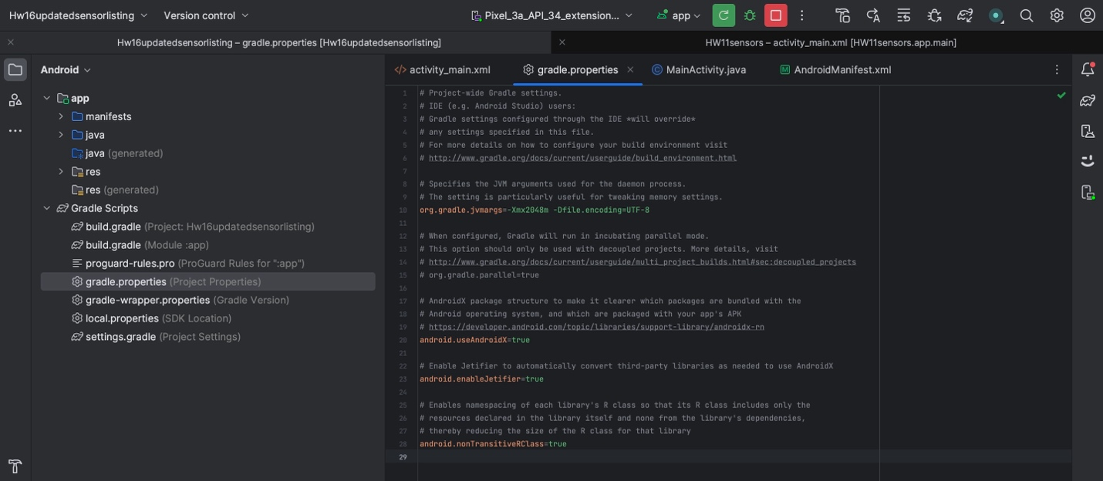

I ran the app on my device for testing as the android studio emulator is not reliable for testing sensors below are the screen shots of the app the app

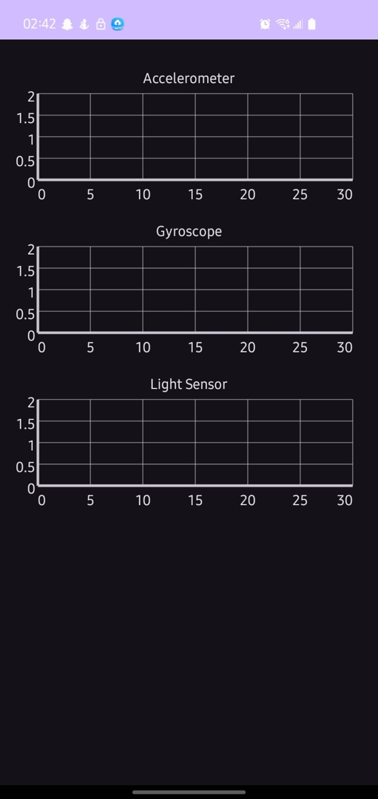
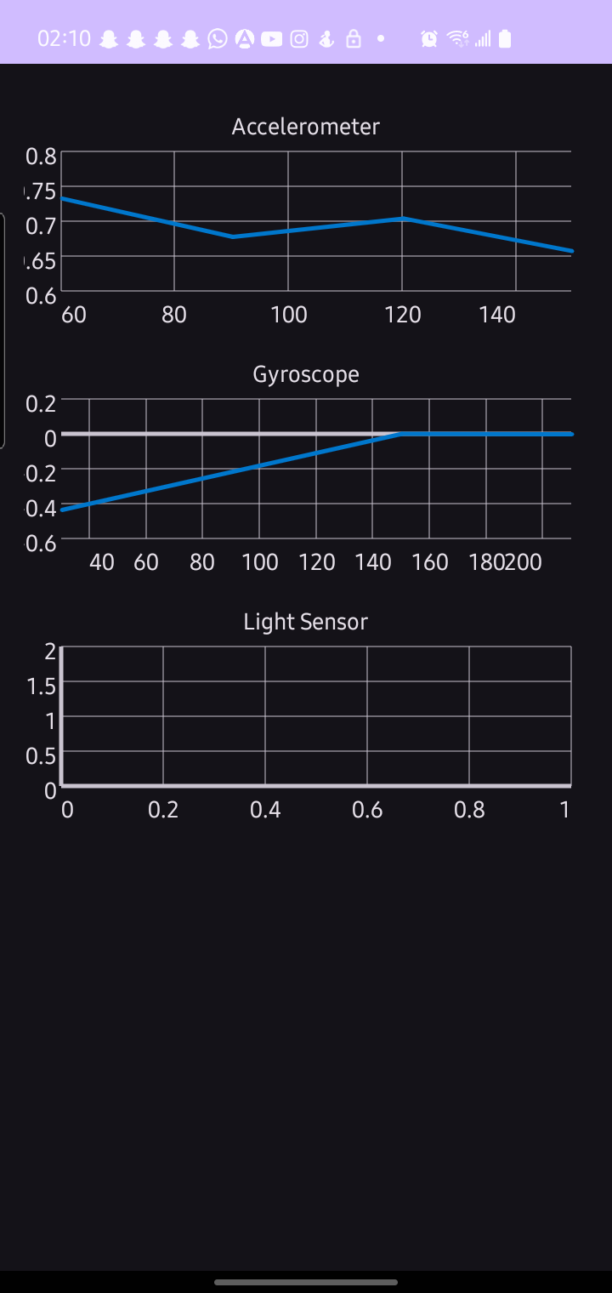
SS1 before testing. SS2 after testing

